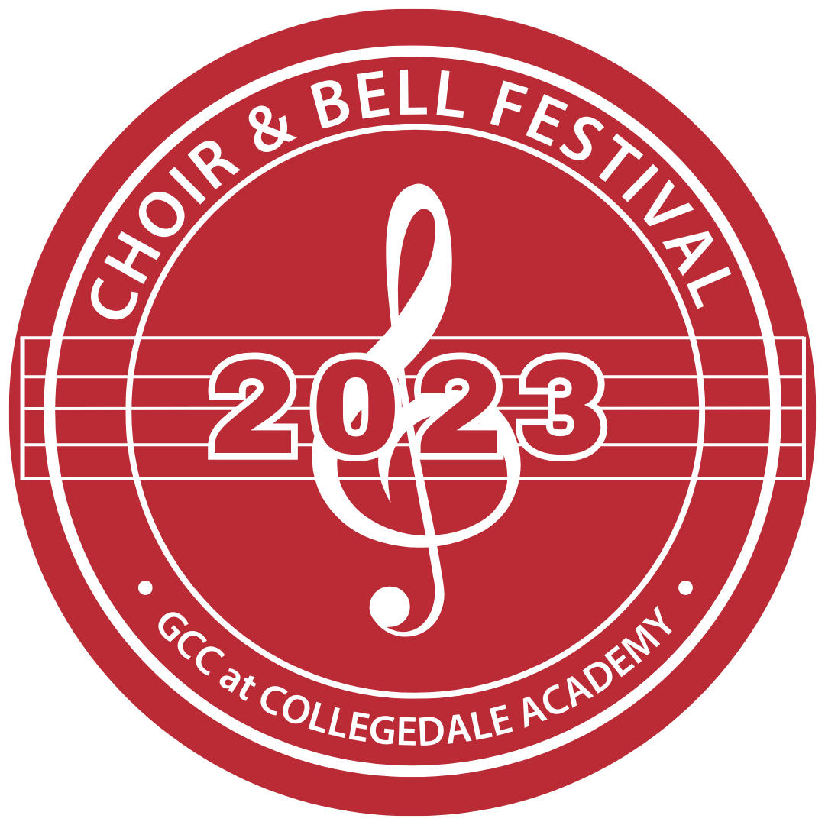
2023 GCC Choir and Bell Festival
Registration Form
Instructions: Please complete the form and email to glindquist@collegedaleacademy.com
Note: Shirt sizing options are adult small through 2XL.

School Name:

Music Director Information:
Name: |  | Cell:

Email: |  | Shirt Size:

Chaperone Information:
First Name | Last Name | Cell Phone | Shirt Size

Student Participant Information:
First Name | Last Name | Grade | Choir or Bells? | Shirt Size

First Name | Last Name | Grade | Choir or Bells? | Shirt Size

First Name | Last Name | Grade | Choir or Bells? | Shirt Size

